NC.2.NBT.5
Using Multiple Strategies to Solve Addition Problems
Domain | Number and Operations in Base Ten
Cluster | Use place value understanding and properties of operations to add and subtract.
Standard(s) | NC.2.NBT.5 Demonstrate fluency with addition and subtraction, within 100, by:  - Flexibly using strategies based on place value, properties of operations, and/or the relationship between addition and subtraction.  - Comparing addition and subtraction strategies, and explaining why they work.  - Selecting an appropriate strategy in order to efficiently compute sums and differences.
Materials | Pencil, Paper, pre-grouped base ten materials, hundreds board
Task | Provide base ten blocks, hundreds board, paper and pencil. Students will choose a tool(s) and strategy needed to find the sums of 46 + 48 and 34 + 29).

Continuum of Understanding
Not Yet Proficient | - No evidence of a procedure or strategy.  - Incorrect solutions  - Uses a strategy that does not help solve the problem  - Prerequisite skills not present  - Explanation is non-existent | Strategy(ies) Used:  - Base ten blocks  - Expanded form  - Adds/subtracts tens & tens  - Add/subtracts ones & ones  - Number line  - Decompose  - Creates easier or known sums  - Doubles  - 1/10 more/less  - Properties of operations  - Other:
Progressing | - Incorrectly solves one or both problems, but  - Some evidence of mathematical reasoning  - Some appropriate use of mathematical representation  - Some parts may be correct, but answer is incorrect  - Relies on counting as primary strategy for solving problem.  - Explanation lacks detail or may not be clearly presented  - Strategy and reasoning could lead to correct answer, but included computational error(s).
Meets Expectation | - Correctly solves both problems.  - Successfully uses place value, properties of operations, or composition or decomposition.  - Uses selected tool efficiently  - Explanation is logical, accurate and illustrates strategies used.

Standards for Mathematical Practice
1. Makes sense and perseveres in solving problems.
2. Reasons abstractly and quantitatively.
3. Constructs viable arguments and critiques the reasoning of others.
4. Models with mathematics.
5. Uses appropriate tools strategically.
7. Looks for and makes use of structure.
8. Looks for and expresses regularity in repeated reasoning.

NBT Task 1 Name_______________________________
NC.2.NBT.5
Formative Instructional and Assessment Task

Can you solve addition problems in more than one way? Solve each problem using a different strategy for each.
Find the sum.
46 + 48 =
Represent your solution using pictures or numbers.

Find the sum.
34 + 29 =

Represent your solution using pictures or numbers. Make sure you use a different strategy than the one used above.

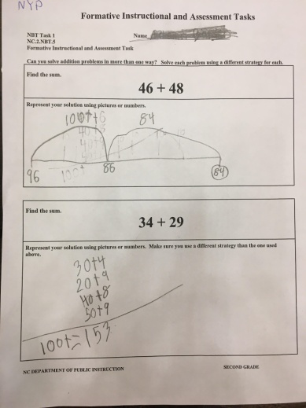
Not Yet Proficient
In problem one, the student doesn’t demonstrate the prerequisite skill needed to accurately solve the problem. It is evident that he has been a part of conversations about using a number line and decomposing numbers, but it is difficult to determine what this student is thinking based on his work.

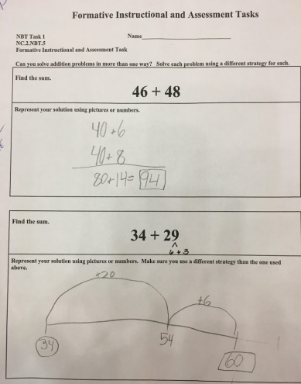
Meets Expectation
This student has correctly answered both problems. In problem one, the student has successfully decomposed both numbers, added the tens and the ones, and composed for a final answer of 94. In problem two, the student decomposes 29 (20 and 9) and represents the appropriate jumps on the number line: 34 + 20 = 54 and 54 + 9 to show an answer of 63.

Progressing
This student correctly solves the first problem using the decomposition strategy. Problem 2 is incorrect. The student has correctly used the number line. The student may have decomposed the 9 in the ones place into 6 + 3, but forgot to make the final jump of 3 on the number line.

