Formative Instructional and Assessment Tasks

NC.2.MD.10
Juan’s Markers
Domain | Measurement and Data
Cluster | Represent and interpret data.
Standard(s) | NC.2.MD.10 Organize, represent, and interpret data with up to four categories.  - Draw a picture graph and a bar graph with a single-unit scale to represent a data set.  - Solve simple put-together, take-apart, and compare problems using information presented in a picture and a bar graph.
Materials | SF, pencil
Task | Provide the materials to the student. Read the problem to the student: Juan measured a handful of markers to the nearest inch. He wrote down each marker’s measurement in a table. Make a bar graph to represent the data.  After the student has created the bar graph and transferred the data say: Look at your data. How many markers did Juan measure? Then say: Describe your data in at least 2 different ways.

Continuum of Understanding
Not Yet Proficient | - Provide instruction on reading and answering questions about bar graphs with three categories. (1st grade NC.1.MD.4) | Checklist for teacher to identify mastery of standard:  - Correctly answers 10 markers  - Describes the data in at least two ways
Progressing | - Incorrectly creates a bar graph.  - Inaccurately transfers the data collected to a bar graph.  - Determines the total number of markers as an amount other than 10.  - Description of data is minimal or incorrect.
Meets Expectation | - Correctly transfers all data to the bar graph correctly.  - Correctly answers the question: 10 markers  - Describes the data in at least 2 different ways (e.g., states amount for each category, notices similarities and differences between category counts, compares categories- more/less)

Standards for Mathematical Practice
1. Makes sense and perseveres in solving problems.
2. Reasons abstractly and quantitatively.
3. Constructs viable arguments and critiques the reasoning of others.
4. Models with mathematics.
5. Uses appropriate tools strategically.
6. Attends to precision.
7. Looks for and makes use of structure.
8. Looks for and expresses regularity in repeated reasoning.

Juan measured a handful of markers to the nearest inch. He wrote down each marker’s measurement in a table.

Juan’s Marker Measurements
9 | 5 | 6 | 8 | 9 | 6 | 8 | 8 | 8 | 8

Make a bar graph to represent the data.

Title _________________________________________________
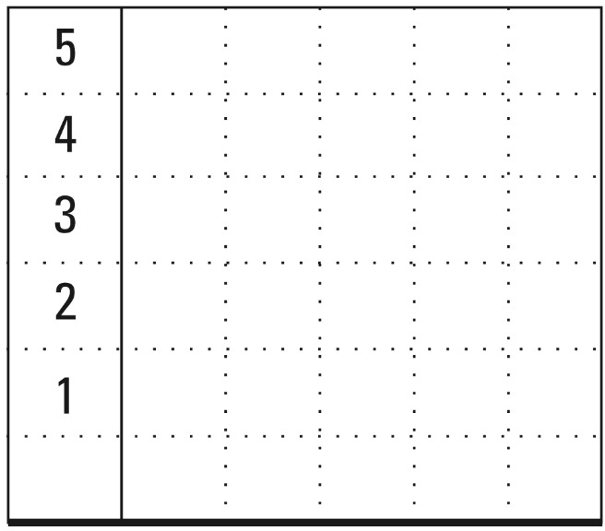

How many markers did Juan measure?

Describe your data in at least 2 different ways.

Scoring Examples

Progressing:

This work describes the data two different ways. There should be 5 markers that are 8 inches. The answer for the total number of markers should be 10.

This work has all the data entered correctly. She wrote one
description of the data rather than two descriptions.

Meets Expectation:

Both of these examples have the data recorded correctly, a correct answer (10 markers) and two different ways to describe the data.

