Name ______________________________ NC.4.MD.6 CFA (Cluster 8)

- The time on the clock below is 4:00. If the hands of the clock were extended, they would intersect the edge of the clock. The arc formed by these two hands would be $\frac{2}{6}$ of the full circle.
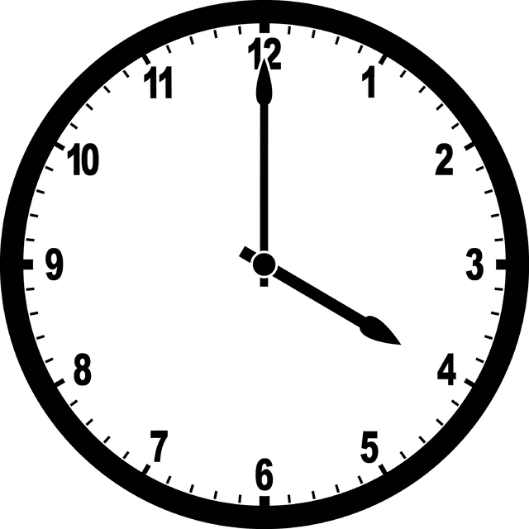
What angle is formed by the hands of the clock?
- 40˚
- 90˚
- 120˚
- 180˚

- What is the measure of the angle shown on the protractor?
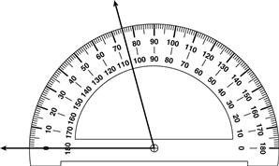
- 115˚
- 105˚
- 85˚
- 75˚

- A garden sprinkler rotates 40˚ every 15 seconds. How long does it take the sprinkler to rotate 360˚?
  - 1 minute
  - 2 minutes 15 seconds
  - 2 minutes 25 seconds
  - 10 minutes

- Which of the following statements is true about Angle A?
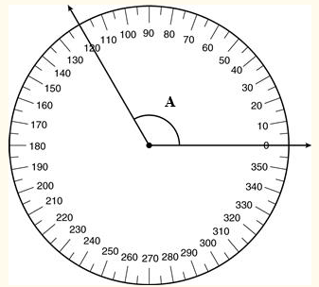
- Both Angle A and the smaller arc on the circle measure 120˚
- Both Angle A and the larger arc on the circle measure 240˚
- Both Angle A and the smaller arc on the circle measure 0˚
- Both Angle A and the smaller arc on the circle measure 240˚

- A video surveillance camera turned 40˚ and paused before continuing to turn. If the camera turned a total of 142˚, how many degrees did the camera turn on the second rotation?
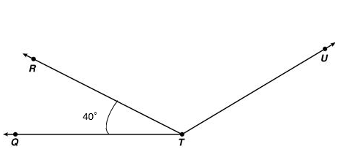
- 182˚
- 180˚
- 102˚
- 100˚

- A museum is building a ramp to make the building wheelchair and stroller accessible. The ramp will have a 20˚ incline. The contractor knows that the measure for one angle of the post should be 70˚. He needs to determine the measure of the missing angle, x, to make sure that the post for the handrail is straight, at 180˚.
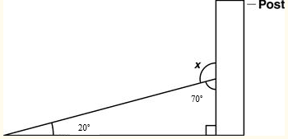
Which should be the value of x, the measure of the missing angle, to make sure the post for the handrail is straight?
- 90˚
- 100˚
- 110˚
- 180˚

- Jasmine drew the figure below.
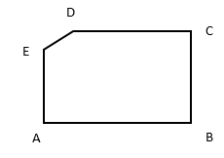
Which measurement is closest to the measure of < D?
- 45˚
- 90˚
- 150˚
- 175˚

- The figure below shows the intersection of streets. Hawthorne St. intersects Chriswood St. at a 110˚ angle. Chriswood St. intersects Larkspur St. at a 40˚ angle.
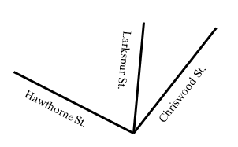
At what angle does Hawthorne St. intersect Larkspur St.?
- 70˚
- 80˚
- 140˚
- 150˚

- A fan moves in a left to right motion before going back from right to left. The fan rotates five degrees each second. If the fan rotated a total of 145 degrees, how many 5 degree turns did the fan make in all?
  - 29
  - 140
  - 290
  - 360

- At the carnival, a Ferris wheel rotates small angles to load and dismount passengers. If the Ferris wheel has rotated 340 degrees already, how many degrees remain to make a full rotation?
  - 360˚
  - 200˚
  - 150˚
  - 20˚

ANSWER KEY

- C
- D
- B
- A
- C
- C
- C
- A
- A
- D

