Good Morning Class!
Today we’re going to be looking at maps and pictures from some of the places we will visit on our field trip to Raleigh! We’re going to have a great time, but we need to look at some of the maps to figure out different routes we can take.

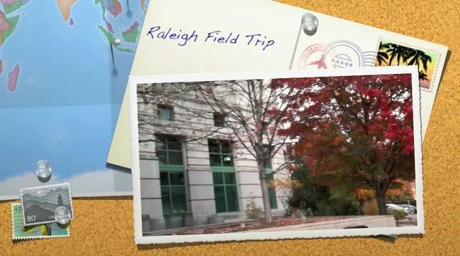

Name: _______________________________
Date: ______________________
First let’s start by looking at our route to get to Raleigh!
- Where will our starting point be? ___________ (Hint: Where is our school located?) Find it on the map and draw a point on the map.

- Where are we going? _____________ (Hint: This is the capital of North Carolina!) Find it on the map and draw a point there!

- Then draw a line segment connecting our points to show our route.
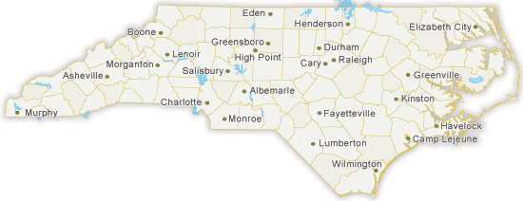

Thomasville

What is the difference between a line segment and a line?

All About Parallel Lines!
I know that parallel means… | Draw a pair of parallel lines:  Now let’s look at the map. Find Wilmington Street and  circle it.  What streets are PARALLEL to Wilmington Street?  Name other pairs of parallel streets. How do you know they are parallel?

All About Perpendicular Lines!
What is the difference between parallel and perpendicular lines? | Draw a pair of perpendicular lines:  Now let’s look at the map. Find Edenton Street and  circle it.  What streets are PERPENDICULAR to Edenton Street?  Name other pairs of perpendicular streets. How do you know they are perpendicular?

All About Intersecting Lines!
What is the difference between perpendicular and intersecting lines? | Draw a pair of intersecting lines:  Now let’s look at the map. Find Hillsborough Street  and circle it.  What streets INTERSECT Hillsborough Street?  Name other pairs of intersecting streets. How do you know they are intersecting?
Geometry can be found all throughout our daily life even ANGLES! Let’s find and identify ALL THE RIGHT ANGLES in the Capitol Building! Use any color you would like to trace the right angles in the picture below.

How many right angles did you find? | Draw a right angle:  How do you know if an angle is a right angle?  Where can you find right angles in our classroom?

Total Number of Right Angles:
Let’s find and identify ALL THE OBTUSE ANGLES in the Legislative Building! Pick a color to trace or highlight the obtuse angles.

How many obtuse angles did you find? | Draw an obtuse angle:  How do you know if an angle is an obtuse angle?  Where can you find obtuse angles in our classroom?

Let’s find and identify ALL THE ACUTE ANGLES in the Natural History Museum’s dinosaur display! Pick out a color for each angle and mark them on the pictures below!

Draw an acute angle:

How do you know if an angle is an acute angle?

Where can you find acute angles in our classroom?

Total Number of Right Angles:

