NC.4.NBT.5
Farmer’s Market
Domain | Number and Operations in Base Ten
Cluster | Use place value understanding and properties of operations to perform multi-digit arithmetic.
Standard(s) | NC.4.NBT.5 Multiply a whole number of up to three digits by a one-digit whole number, and multiply up to two two-digit numbers with place value understanding using area models, partial products, and the properties of operations. Use models to make connections and develop the algorithm.
Materials | activity sheet, pencil
Task | Farmer’s Market  Part 1:  Farmer Brown delivered 6 crates filled with corn to the farmer’s market. Each crate contained 1,197 ears of corn. How many ears of corn did Farmer Brown deliver?  Part 2:  Farmer Smith also delivered 6 crates of corn to the farmer’s market. Each crate contained 874 ears of corn. How many ears of corn did Farmer Smith deliver?  Part 3:  How many more ears of corn did Farmer Brown deliver than Farmer Smith?

Rubric
Level I  Not Yet | Level II  Progressing | Level III  Meets Expectation
Student is unable to use strategies to find correct answers to any aspect of the task. | Student answered 1-2 parts of the problem correctly. | All answers are correct.  Part 1: 1,197 x 6 = 7,182  Part 2: 874 x 6 = 5,244  Part 3: 7,182 - 5,244 = 1,938

Standards for Mathematical Practice
1. Makes sense and perseveres in solving problems.
2. Reasons abstractly and quantitatively.
3. Constructs viable arguments and critiques the reasoning of others.
4. Models with mathematics.
5. Uses appropriate tools strategically.
6. Attends to precision.
7. Looks for and makes use of structure.
8. Looks for and expresses regularity in repeated reasoning

Farmer’s Market

Part 1:
Farmer Brown delivered 6 crates filled with corn to the farmer’s market. Each crate contained 1,197 ears of corn. How many ears of corn did Farmer Brown deliver?

Part 2:
Farmer Smith also delivered 6 crates of corn to the farmer’s market. Each crate contained 874 ears of corn. How many ears of corn did Farmer Smith deliver?

Part 3:
How many more ears of corn did Farmer Brown deliver than Farmer Smith?

Scoring Examples

Not Yet: The student was unable to use strategies to solve any part of the task correctly. The student attempted to use repeated addition to solve the problem, but made calculation errors.
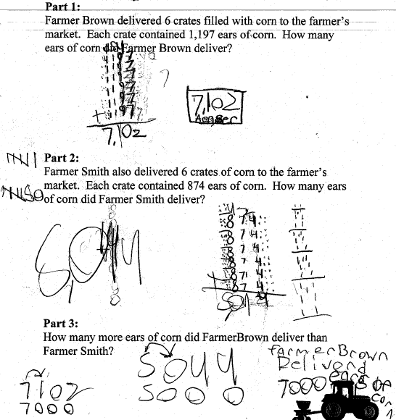

Progressing: The student was able to answer Part 1 and Part 2 correctly using multiplication strategies, but was unable to find the correct answer for Part 3, which required subtraction.

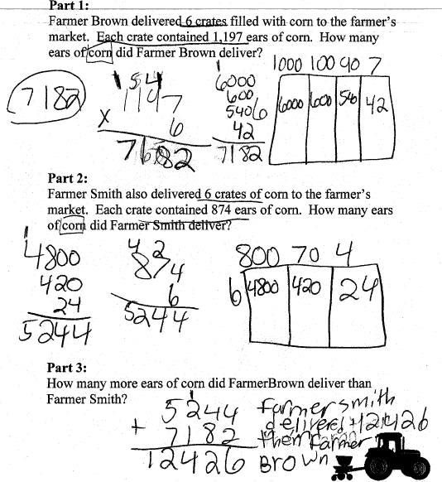

Meets Expectation: The student was able to answer all parts of the task correctly.
