NC.4.MD.3
Remodeling the School
Domain | Measurement and Data
Cluster | Solve problems involving area and perimeter.
Standard(s) | NC.4.MD.3 Solve problems with area and perimeter.  - Find areas of rectilinear figures with known side lengths  - Solve problems involving a fixed area and varying perimeters and a fixed perimeter with varying areas  - Apply the area and perimeter formulas for rectangles in real world and mathematical problems
Materials | activity sheet, pencil
Task | Remodeling the School  Pikeville Elementary School wants to build an addition on to the school to make more room for the fourth and fifth grade students. The builder has proposed two floor plans that have identical perimeters of 316 meters. Which of the two floor plans would provide the greatest square footage for the students and teachers? Use drawings, numbers, equations, and/or words to explain how you found your answer.  Solutions:  Floor Plan B:  Perimeter – 316 meters  Area – 2,991 square meters  Floor Plan A:  Perimeter – 316 meters  Area – 2,835 square meters  *Floor Plan B provides the most square footage.

Rubric
Level I  Not Yet | Level II  Progressing | Level III  Meets Expectation
Student is able to do 0-2 of the following:  - Break up each floor plan into smaller rectangles  - Use existing side lengths to figure out side lengths of smaller rectangles  - Calculate area for each small rectangle  - Generate total area for each floor plan  - Justify reasoning for each answer using drawings, numbers, words, or equations | Student is able to do 3-4 of the following:  - Break up each floor plan into smaller rectangles  - Use existing side lengths to figure out side lengths of smaller rectangles  - Calculate area for each small rectangle  - Generate total area for each floor plan  - Justify reasoning for each answer using drawings, numbers, words, or equations | Student is able to do ALL of the following:  - Break up each floor plan into smaller rectangles  - Use existing side lengths to figure out side lengths of smaller rectangles  - Calculate area for each small rectangle  - Generate total area for each floor plan  - Justify reasoning for each answer using drawings, numbers, words, or equations

Standards for Mathematical Practice
1. Makes sense and perseveres in solving problems.
2. Reasons abstractly and quantitatively.
3. Constructs viable arguments and critiques the reasoning of others.
4. Models with mathematics.
5. Uses appropriate tools strategically.
6. Attends to precision.
7. Looks for and makes use of structure.
8. Looks for and expresses regularity in repeated reasoning

Remodeling the School
Pikeville Elementary School wants to build an addition on to the school to make more room for the fourth and fifth grade students. The builder has proposed two floor plans that have identical perimeters of 316 meters. Which of the two floor plans would provide the greatest square footage for the students and teachers? Use drawings, numbers, equations, and/or words to explain how you found your answer.

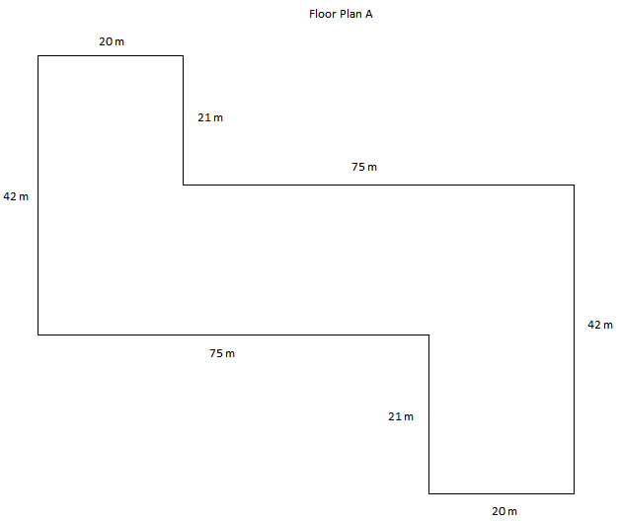
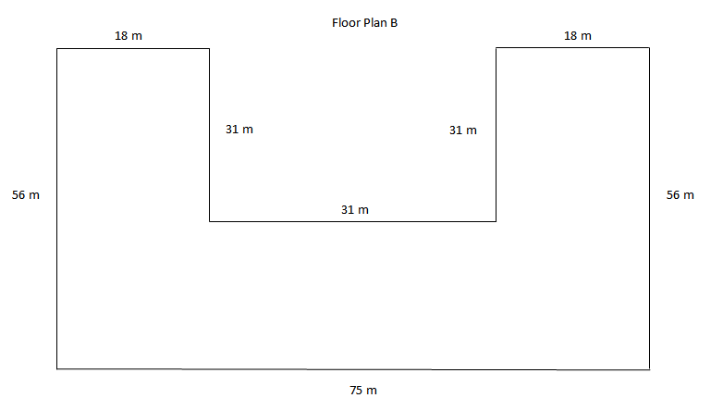
Which floor plan would provide the greatest square footage?

Explain how you solved this task using drawings, numbers, equations, and/or words.

Scoring Examples
Not Yet: The student is unable to find the correct area for either floor plan and does not give a correct explanation for how the problem was solved.
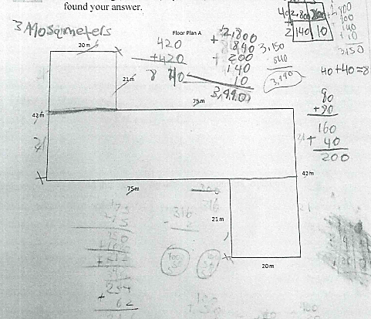
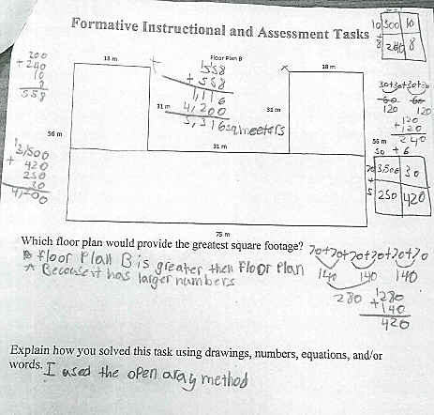
Progressing: The student correctly found the area for one floor plan, but not the other. The student could explain the strategy used to solve.
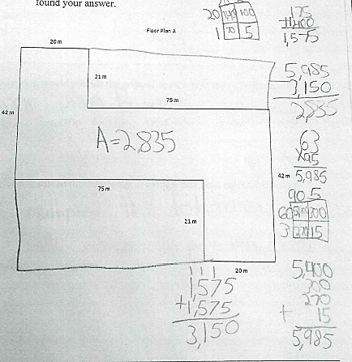
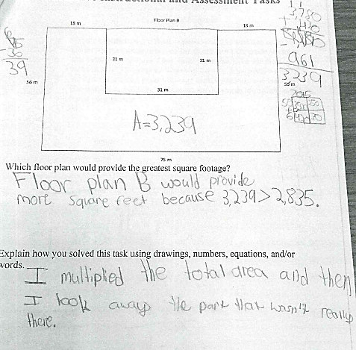
Meets Expectations: The student found the area for both floor plans, correctly compared them, and explained the strategy used for solving the problem completely and correctly.
