NC.4.MD.8
How Much Longer Until Recess?
Domain | Measurement and Data
Cluster | Solve problems involving measurement.
Standard(s) | NC.4.MD.8 Solve word problems involving addition and subtraction of time intervals that cross the hour.
Materials | handout, pencil
Task | How Much Longer Until Recess?  Rashida is a fourth grader in Mrs. Thompson’s fourth grade class. Below is the daily classroom schedule for Mr. Thompson’s fourth grade class.  Daily Schedule  Start Time Subject  8:10 am Reading  9:20 am Writing  9:50 am Social Studies  10:20 am Spelling  10:35 am Math  11:15 am Science  12:05 pm Lunch  1:05 pm Recess  1:45 pm Computer Lab  2:25 pm Dismissal  Part One:  Although she hasn’t been at school very long, Rashida can’t stop daydreaming about going out to recess. If writing time has just started, how long will it be before she is able to go out for recess? (3 hours 45 minutes)  Part Two:  If Rashida’s basketball practice begins 3 hours and 50 minutes after dismissal, what time does her basketball practice begin? (6:15 pm)

Rubric
Level I  Not Yet | Level II  Progressing | Level III  Meets Expectation
Student is able to correctly complete no parts of the task. | Student is able to correctly complete 1 part of the task. | Student is able to correctly complete all parts of the task.

Standards for Mathematical Practice
1. Makes sense and perseveres in solving problems.
2. Reasons abstractly and quantitatively.
3. Constructs viable arguments and critiques the reasoning of others.
4. Models with mathematics.
5. Uses appropriate tools strategically.
6. Attends to precision.
7. Looks for and makes use of structure.
8. Looks for and expresses regularity in repeated reasoning.
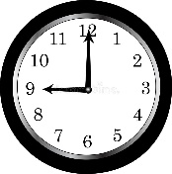
How Much Longer Until Recess?

Rashida is a fourth grader in Mrs. Thompson’s fourth grade class. Below is the daily classroom schedule for Mr. Thompson’s fourth grade class.

Daily Schedule
Start Time | Subject
8:10 am | Reading
9:20 am | Writing
9:50 am | Social Studies
10:20 am | Spelling
10:35 am | Math
11:15 am | Science
12:05 pm | Lunch
1:05 pm | Recess
1:45 pm | Computer Lab
2:25 pm | Dismissal

Part One:
Although she hasn’t been at school very long, Rashida can’t stop daydreaming about going out to recess. If writing time has just started in Rashida’s class, how long will it be before she is able to go out for recess?

Part Two:
If Rashida’s basketball practice begins 3 hours and 50 minutes after dismissal, what time does her basketball practice begin?

Scoring Examples
Not Yet: Student is unable to correctly complete either part of the task. The use of the standard subtraction algorithm to solve shows a misunderstanding as to how elapsed time works.
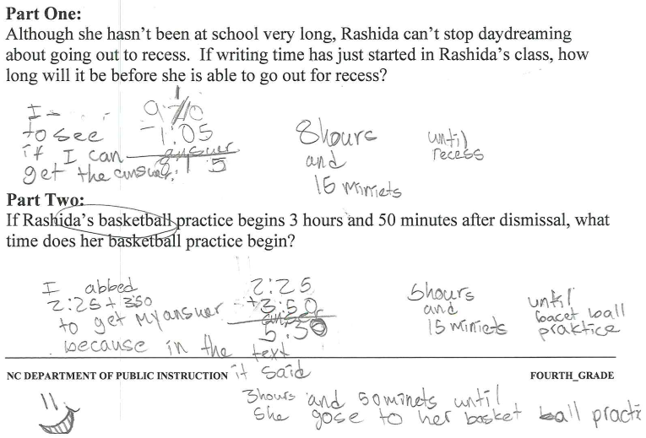

Progressing: The student is using a counting strategy, but is only able to correctly solve Part 2 of the task.
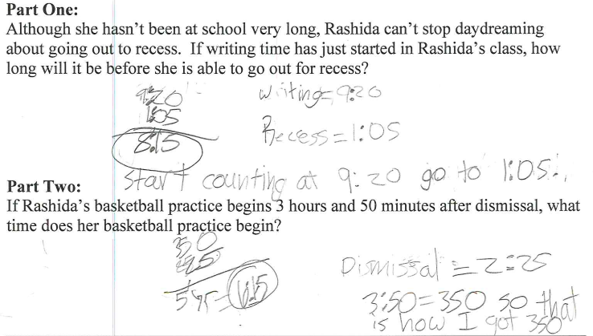

Meets Expectation: The student is able to correctly solve for all parts of the task.
