Technology for Math Practice
https://www.splashmath.com/
Splash Math is a complete K-5 math learning program that is built, aligned, and personalized to your child’s specific needs.

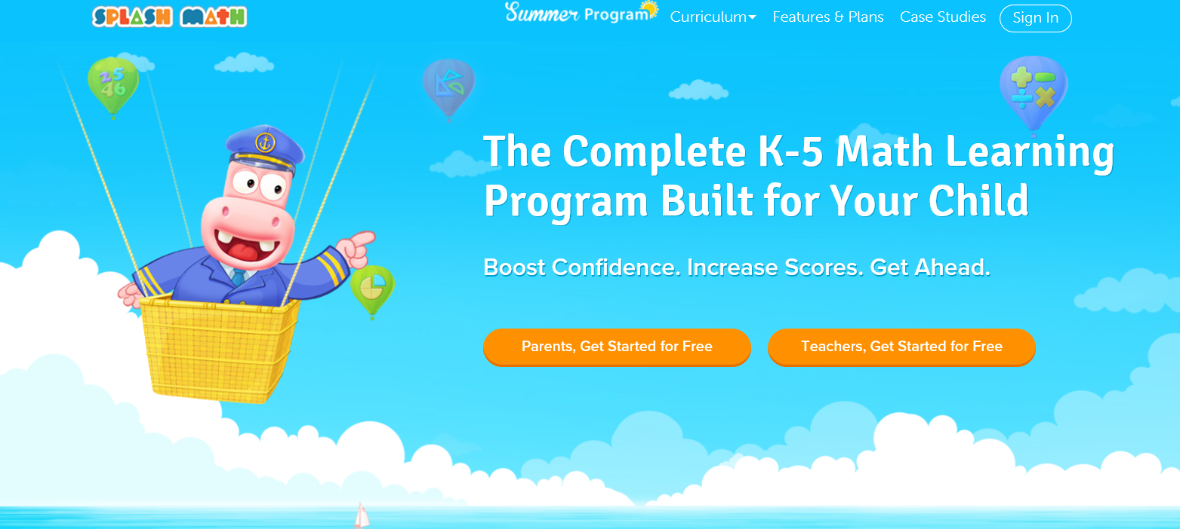

http://www.abcya.com/first_grade_computers.htm#numbers-cat
ABCya is a teacher-created website which provides fun and educational games and apps for children. ABCya is an award-winning site that offers hundreds of engaging learning activities.
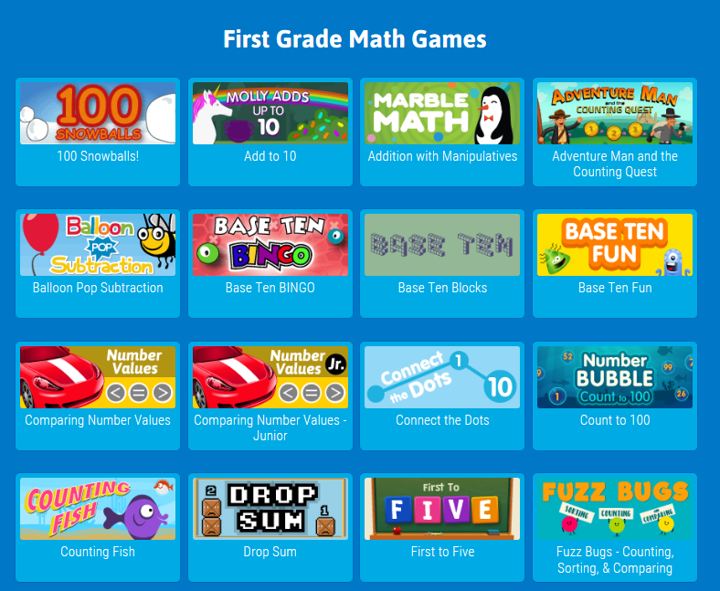
https://www.education.com/games/first-grade/math/
First grade math games get kids excited about addition and subtraction. They can make pizzas and play game shows to practice addition and subtraction skills.
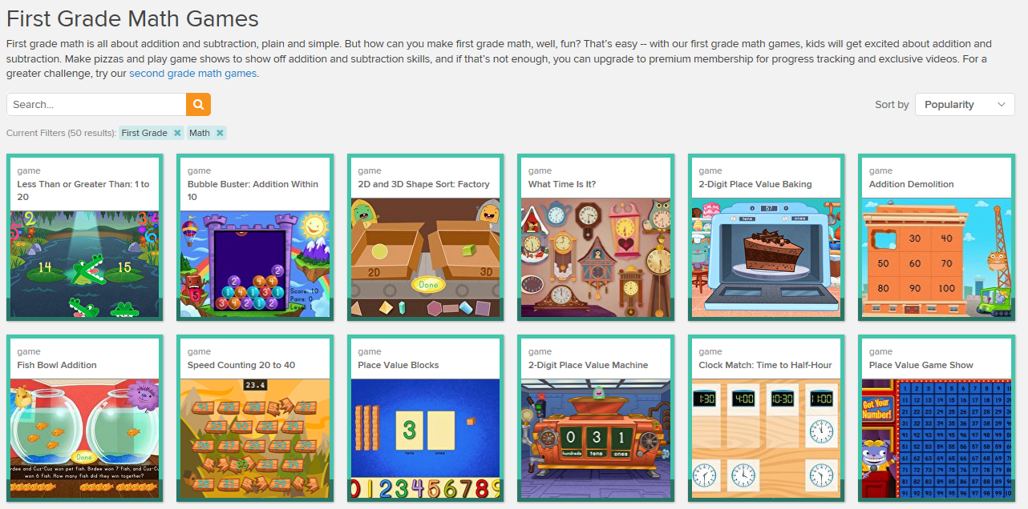
http://www.futuristicmath.com/1st-grade-math-games.html
First grade interactive online games help students master skills and practice facts through fun activities.

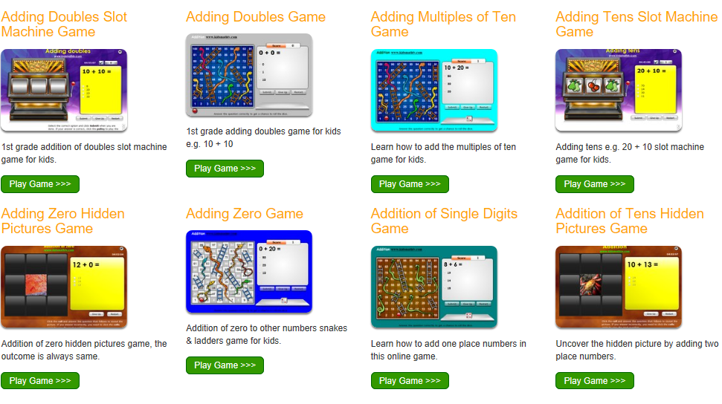

http://www.futuristicmath.com/1st-grade-math-board-games.html
First grade printable board games help your child develop a variety of math skills through play.
http://www.mathabc.com/math-1st-grade
This site includes free math games that are aligned with 1st grade standards.
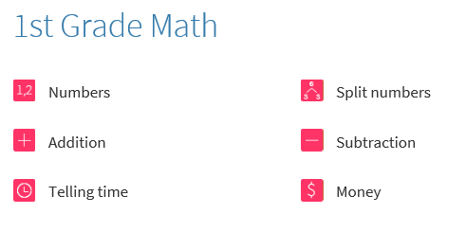
https://www.mathplayground.com
This website offers a variety of math games to practice multiple math concepts.

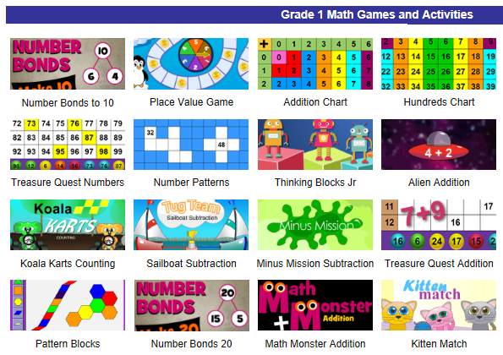

https://www.coolmath4kids.com
This site is an amusement park full of games, lessons, and more designed to teach math and make it FUN.
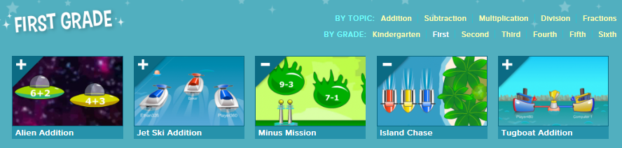
http://gregtangmath.com/index
Greg Tang Math is a site developed by a mathematician who focuses on improving fluency. In addition to interactive online games, this site offers free printable materials and resources to help students build important math skills.

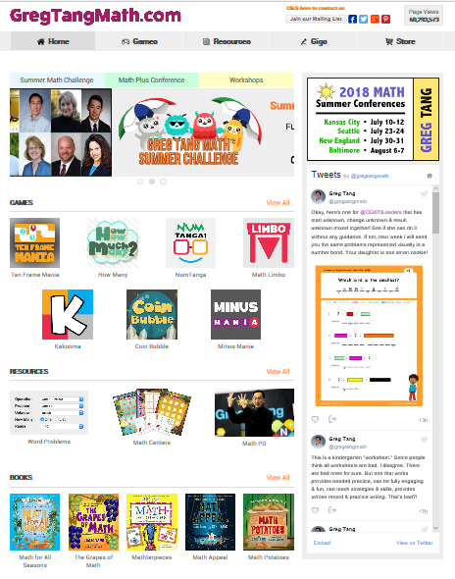

Technology for Math Practice Handout
https://www.splashmath.com/
Splash Math is a complete K-5 math learning program that is built, aligned, and personalized to your child’s specific needs.
http://www.abcya.com/first_grade_computers.htm#numbers-cat
ABCya is a teacher-created website which provides fun and educational games and apps for children. ABCya is an award-winning site that offers hundreds of engaging learning activities.
https://www.education.com/games/first-grade/math/
First grade math games get kids excited about addition and subtraction. They can make pizzas and play game shows to practice addition and subtraction skills.
http://www.futuristicmath.com/1st-grade-math-games.html
First grade interactive online games help students master skills and practice facts through fun activities.
http://www.futuristicmath.com/1st-grade-math-board-games.html
First grade printable board games help your child develop a variety of math skills through play.
http://www.mathabc.com/math-1st-grade
This site includes free math games that are aligned with 1st grade standards.
https://www.mathplayground.com
This website offers a variety of math games to practice multiple math concepts.
https://www.coolmath4kids.com
This site is an amusement park full of games, lessons, and more designed to teach math and make it FUN.
http://gregtangmath.com/index
Greg Tang Math is a site developed by a mathematician who focuses on improving fluency. In addition to interactive online games, this site offers free printable materials and resources to help students build important math skills.

