Five Numbers Bingo
In this lesson, students compare two-digit numbers based on the meanings of the tens and ones digits.

NC Mathematics Standard:
Understand place value.
NC.1.NBT.3 Compare two two-digit numbers based on meanings of the tens and ones digits, recording the results of comparisons with the symbols >, =, <.

Additional/Supporting Standards:
Extend and recognize patterns in the counting sequence.
NC.1.NBT.1 Count to 150, starting at any number less than 150.

Understand place value.
NC.1.NBT.2 Understand that the two digits of a two-digit number represent amounts of tens and ones.
• Unitize by making a ten from a collection of ten ones.
• Model the numbers from 11 to 19 as composed of a ten and one, two, three, four, five, six, seven, eight, or nine ones.
• Demonstrate that the numbers 10, 20, 30, 40, 50, 60, 70, 80, 90 refer to one, two, three, four, five, six, seven, eight, or nine tens, with 0 ones.

Standards for Mathematical Practice:
2. Reason abstractly and quantitatively.
3. Construct viable arguments and critique the reasoning of others.
4. Model with mathematics.
7. Look for make use of structure.

Student Outcomes:
- I can compare 2 two-digit numbers.
- I can identify the value of a two-digit number based on the number of tens and ones.

Math Language:
What words or phrases do I expect students to talk about during this lesson?
less, more, ones, tens, value, digits

Materials:
- Bingo Game Boards, Hundred Boards, Number Cards (0-9), two number dice, whiteboard, markers

Advance Preparation:
- Gather materials and prepare Bingo Game Boards, Hundred Boards, Number Cards (0-9)
Launch
- Numbers on the Hundred Board (5-10 minutes)
Distribute hundred boards to students. Have the students find the numbers 56 and 65 on the hundred boards.

Possible questions to ask:
- What do you notice about these numbers?
- How many tens does each number have?
- Which number is greater?
- How do you know?

Continue with two other pairs of numbers such as 68 and 86, then 28 and 82.
Help students focus on the idea that the changing position of digits in the tens and ones place changes the value of the number.

Explore
- Five Numbers Bingo (15-20 minutes)
Students can play with partners or with a partner in a group of 4 students. Roll two number dice or pull two number cards at the same time to generate two digits. Students will write down on their whiteboard the two two-digit numbers that can be formed. For example, a 2 and an 8 could make 28 or 82. Students mark both of those numbers on their hundred board. On their Five Numbers Bingo board, students can write one of those numbers in the appropriate row. Note: each row covers 20 numbers (0-19, 20-39, 40-59, 60-79, 80-99). The goal is to get 5 numbers in a row (vertically, horizontally, diagonally) on their Five Numbers Bingo board in the fewest turns as possible.

Variations:
This game can be modified so students can only win if they have:
- 5 in a row vertically
- 5 in a row horizontally
- 5 in a row diagonally
- 2 5s in a row

Discuss
- Discussion (8-10 minutes)
Bring the class back together for a discussion. Show students a game board that has 4 numbers filled in on a row. Example: 25, 28, 32, 36, blank square. Show the digits 3 and 5.
Possible questions to ask:
- What two numbers could we make?
- For our game, which is the best number to make? Why?
Give them another situation or two if time permits and ask the same questions.

Additional Activity (if needed)
Students should show their work in their math journals. Give students the following set of digits: 3, 3, 5, 5, 5, 8. Tell them to select two digits at a time to make different two-digit numbers. Digits can only be used once.
Possible questions to ask:
- Can you create numbers that all have the same number of tens?
- Can you create numbers that all have the same number of ones?

Evaluation of Student Understanding
Informal Evaluation:
Observe and monitor students during the game to note if they are solving problems using place value understanding. Notice if students are:
- quickly determining the numbers they want to use on the game board
- representing two-digit numbers correctly on the hundred board
- explaining their strategy for determining the value of two-digit numbers

Formal Evaluation/Exit Ticket:
Student work from the Additional Activity can be used as a formal evaluation. See if students correctly make two-digit numbers that fit the requirements you request.

Meeting the Needs of the Range of Learners
Intervention:
Working with a partner or in a small group will help struggling students. Roll the dice and have children to write the 2 numbers that can be made with the 2 digits. Discuss how the 2 numbers are different. Allow students to build the numbers with groupable manipulatives so they can compare the 2 numbers. Children can then locate the 2 numbers on the hundred boards.

Extension:
The numbers in red on Five Numbers Bingo board were placed on the board to help children with the order of the numbers. The red numbers may be removed for children that do not need the assistance. Children may write the numbers in order from least to greatest in each row which adds difficulty to the game. During the Additional Activity, students could be challenged to make three different two-digit numbers.

Possible Misconceptions/Suggestions:
Possible Misconceptions | Suggestions
If students are searching all over the hundred board for a specific number, students may not realize that a row on the hundred board is also a group of 10. | Give students practice laying snap cubes (ten on a row) on the hundreds board, or locating the groups of tens and ones with markers on a hundred board.
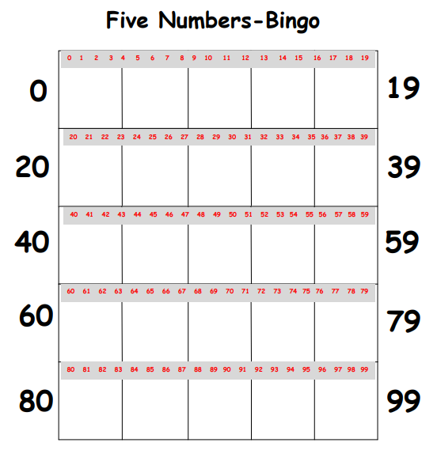
Hundred Boards
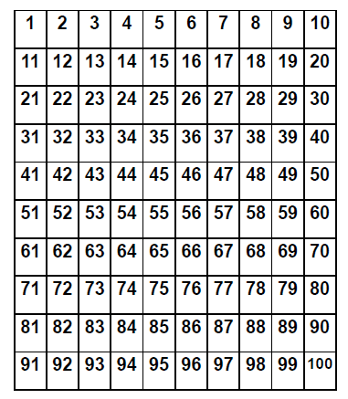

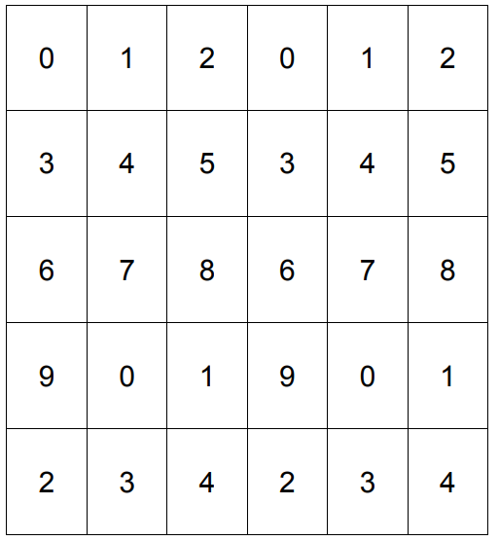
Number Cards (0-9)

