Conceptual Subitizing Cards (set 1)

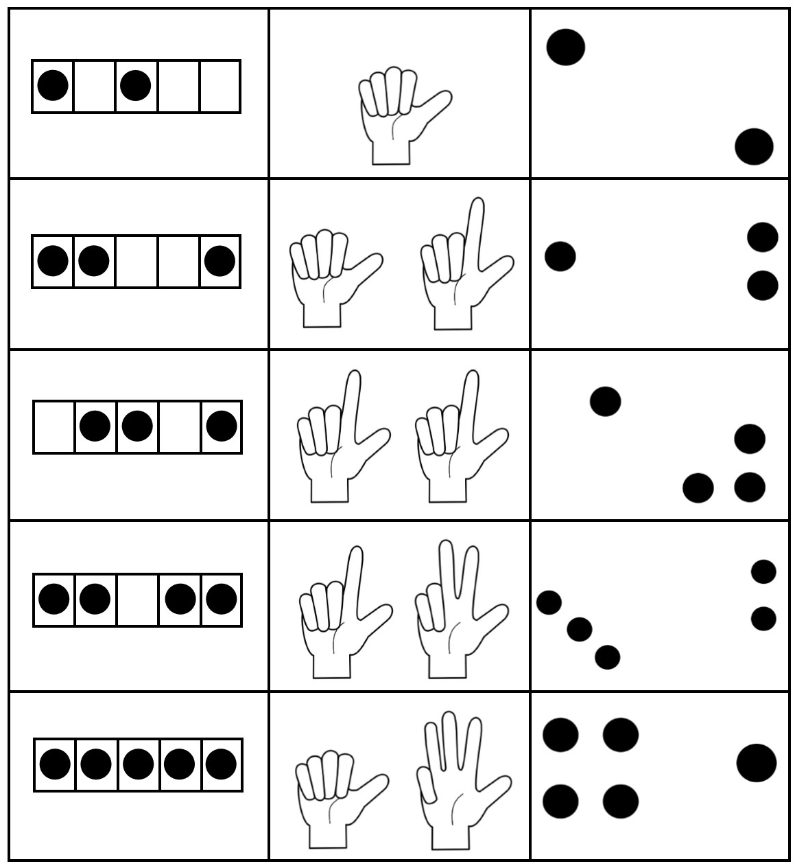
Conceptual Subitizing Cards (set 2)

