Introduction to Sorting Quadrilaterals

In this lesson, students explore various quadrilaterals by sorting them based on attributes such as opposite sides having equal lengths and square corners (right angles).

NC Mathematics Standards:
Geometry: Reason with shapes and their attributes.
NC.3.G.1 Reason with two-dimensional shapes and their attributes.
● Investigate, describe, and reason about composing triangles and quadrilaterals and decomposing quadrilaterals.
● Recognize and draw examples and non-examples of types of quadrilaterals including rhombuses, rectangles, squares, parallelograms, and trapezoids.

Standards for Mathematical Practice:
3. Construct viable arguments and critique the reasoning of others.
6. Attend to precision.

Student Outcomes:
- I can sort quadrilaterals by attributes.
- I can communicate with precision about the attributes of quadrilaterals as well as how shapes are similar and different from each other.

Math Language:
- Corner (angle), equal, quadrilateral, side

Materials:
- Launch activity to project or copies for the class
- Defining Quadrilaterals Cards for each pair
- Student handouts

Advance Preparation:
- Gather materials.

Launch:
- Defining Quadrilaterals (8-10 minutes)
Have students look closely at the various pictures of rhombuses (attached) and draw them in their math notebook. Then have students record observations about rhombuses. Repeat with squares.

Ask students, “What would need to be done to this rhombus to make it a square? Why is there a square in the group of rhombuses?”

After students have some time to think and write independently, have them get into groups of 4 and create a statement: For a rhombus to become a square…

Students are going to spend time looking at various types of quadrilaterals. Ask what a quadrilateral is. Students should be able to state that it is a 4-sided polygon, and polygons are closed figures with straight sides whose sides have no gaps or overlaps.

Explore:
- Exploring Quadrilaterals (20-25 minutes)
Pair students up, and provide them with the quadrilateral cards (attached). Allow students to work in pairs or groups of 3 to sort the cards. Students should be encouraged to sort their cards however they choose.

If students get stuck, suggested sorts could be:
- 1 pair of opposite sides that have equal length
- 2 pairs of opposite sides that have equal length
- 1 square (right) angle
- 2 square (right) angles

Table 1 provides possible questions to pose based on students’ work on the observation.

Table 1. Questions to ask as students explore.
Observation | Questions to Ask
Students cannot identify which sides have equal length. | - “Which side lengths look like they may be the same? How can you check?”  - “How can you use a ruler to examine the side lengths of the shape?”
Students cannot identify which shapes have a square (right) corner. | - “Which shapes look like they may have square corners?”  - “How can you check to see if a shape has a square corner?”  - “How can this plastic square tile help you determine if the shape has a square corner?”

Discuss:
- Discussion of Sorting Quadrilaterals (15 minutes)
Discuss students’ strategies for sorting and answers.

Table 2 provides some sample questions and possible sentence frames to support the class discussion.

Table 2. Sample Questions to Facilitate Classroom Discourse
Sample Questions | Possible Responses or Talk Frames
- What strategies did you use to sort and organize your shapes? | - “I sorted them by shapes that 2 or more sides that were equal length.”  - “I sorted them by shapes that had opposite sides that were equal length.”  - “I sorted them by shapes that had a square corner.”
- How would you describe Shape K in terms of opposite side lengths being equal and square corners? | - “I think that Shape K has opposite sides that are equal length but has no square corners.”
- How would you describe Shape K in terms of opposite side lengths being equal and square corners? | - “I think that Shape M has one square corner but no sides that are the same length.”
- How would you describe Shape A in terms of opposite side lengths being equal and square corners? | - “I think A should go in the middle since it has 4 square corners and the opposite sides have the same length.”

Display the following words on the board: parallelogram, trapezoid, square, rectangle, rhombus. Ask students questions such as,
- “Can you identify examples of a ____ in the cards we worked with today?”
- “What makes Shape __ a(n) _______?”
- “Take a look at Shapes A and N. What do they have in common? How are they different?” Emphasize the attributes of opposite sides moving in the same direction (parallel), opposite side lengths being equal, and the number of square corners (right angles).

Close the lesson by asking students, “What are ways that you sorted quadrilaterals today?”’

Evaluation of Student Understanding:
Informal Evaluation:
- Observe students and ask questions as they are completing the explore task. Pay attention to how students are determining equal side lengths and square corners.

Formal Evaluation:
- Students’ work during the Explore phase can be used as a formal evaluation. The exit ticket (attached) provides an opportunity for students to demonstrate whether or not they can sort shapes based on the attributes of side length and square corners.

Meeting the Needs of the Range of Learners:
Interventions:
- For students who struggle with the large number of cards, use a smaller set that includes Cards A, D, E, and J.

Extensions:
- Students can begin to sort shapes in the double Venn diagram and choose how they will label them. One label should be related to side lengths and one label should be about square corners (right angles).

Special Notes:
- The Explore activity could be repeated as a center activity in future lessons by having students sort the shapes in various ways.

Launch Activity
Directions:
Look closely at the shapes in each group. What do all of the shapes in the group have in common? What do you notice about the length of the sides? What do you notice about the corners? Will the opposite sides ever meet each other?

These are all rhombuses.

Observations about rhombuses

These are all squares.

Observations about squares.

When does a rhombus become a square?

Sorting Quadrilaterals Cards
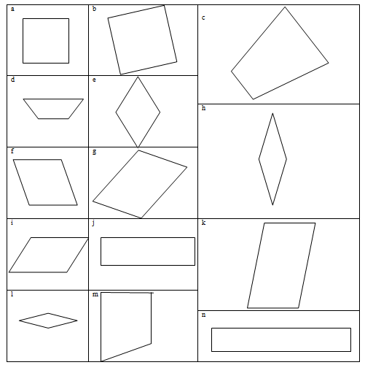

A
B
C
D
E
Place the shapes in the correct area of the Venn diagram below.

All opposite sides equal in length No square corners

